**Functional Document**

|  |  |
| --- | --- |
| **Application** | NGERP - Centra |
| **Service Bundle** | Sales Management |
| **Service Request** | Payment Out AR |

**Description :**

Payment out AR is used to make payment to Commercial discount invoice and to allocate them with payment netoff. There are only two document types in Payment out AR cash receipt and AP payment.

**Workflow Process :**

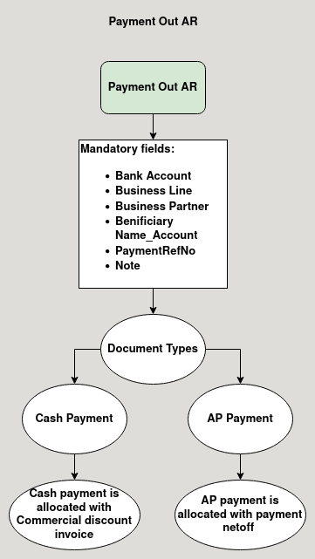

**Business Rules :**

* Payment out AR is loaded in the payment allocation screen.
* Payment out AR screen is used to make payment to commercial discount invoice
* It is also used to allocate with payment netoff.
* There are two document types in payment out AR
  + AP Payment
  + Cash Payment
* Cash payment is used to make payment to commercial discount invoices.
* AP payment document type is used to allocate it with Payment netoff.